Planning Document: Fully-functional TransLink Data Parser
1) Dataset and Task
Dataset: The dataset consists of two types of data:
- Static Data: A group of SEQ_GTFS .txt files in CSV format. These include:
  - agency.txt: Information about the transit agencies.
  - routes.txt: Data about different routes available in the transit system.
  - stops.txt: Details about all the stops, including names, locations, and associated information.
  - trips.txt: Details about trips, including the specific route and service each trip belongs to.
  - stop_times.txt: Schedule details for each stop in each trip.
  - calendar.txt and calendar_dates.txt: Information about service availability on specific dates.
  - shapes.txt: Geographical shapes of the routes.
- Live Data: JSON files fetched from an API, which are updated regularly to provide real-time information:
  - trip_updates.json: Contains updates on trip statuses, including delays and cancellations.
  - vehicle_positions.json: Tracks the real-time positions of vehicles.
  - alerts.json: Provides information about service alerts, disruptions, or changes.
Task: Build a command-line application that parses both static and live data to provide up-to-date transit information based on user inputs. User input includes “What Bus Route would you like to take?”, “What is your start and end stop on the route?”, “What date will you take the route?” and “What time will you leave?”. After receiving all inputs from user, the app will output the table of route’s short name and long name, trip’s service Id and head sign, scheduled arrival time and live arrival time of the vehicle at the starting stop, live geographic position of vehicle and finally the estimated time from the start stop to destination stop. The app also allow user to search again and handling edge cases.

2) Important Fields and Joins
- service_id: The key field linking the calendar, calendar_dates, and trips datasets, specifying the service schedule.
- route_id: Links the routes, trips, and shapes datasets, defining the route each trip belongs to.
- trip_id: Connects the trips dataset to stop_times and is used for correlating live trip updates.
- stop_id: A common field between stops and stop_times used to identify specific stops within a trip.
- shape_id: Links the shapes dataset to trips for mapping the geographical layout of routes.
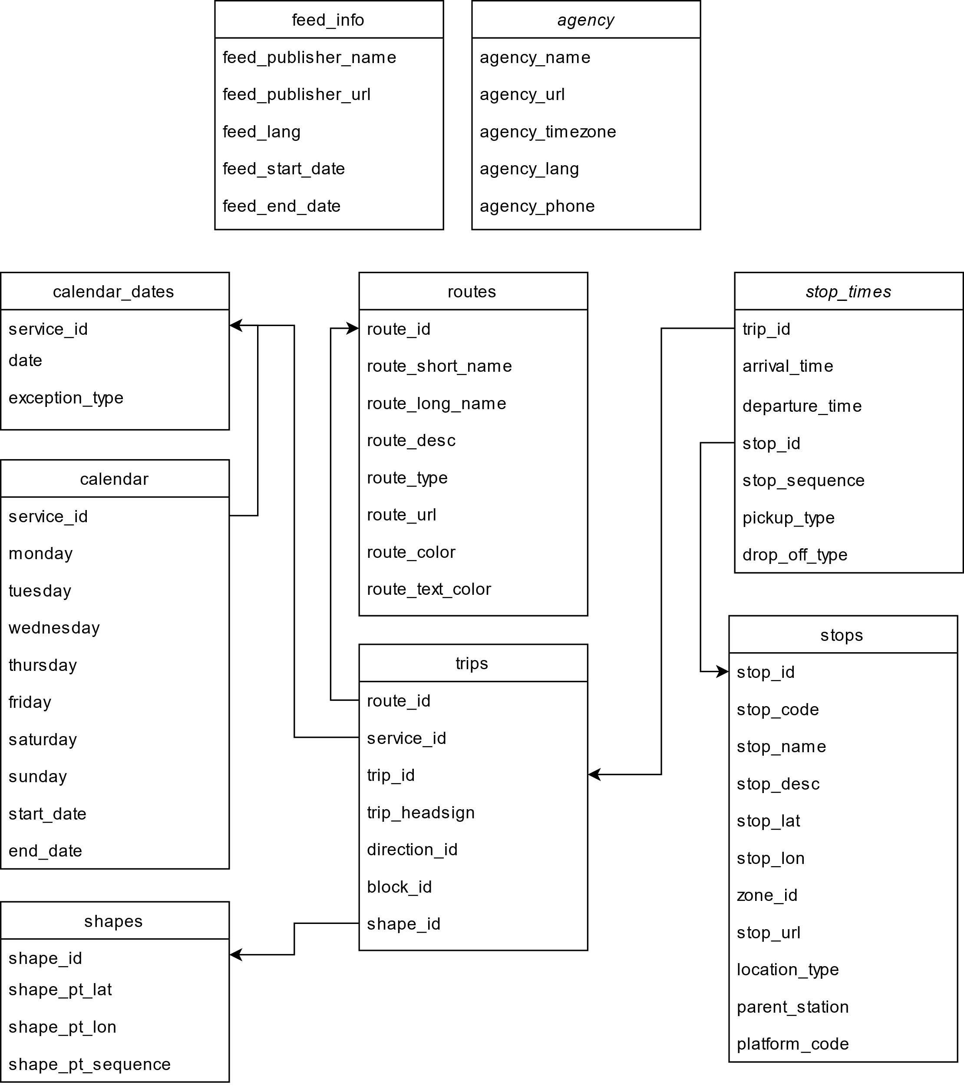

3) Steps to Perform the Task
- Implement a module that will serve as a dataframe
  - Create a dataframe that can load a CSV file into a dataframe, join two CSV files on a common field, select specific columns from a dataframe, return distinct values from a column and filter columns of a dataframe using criteria involving comparison operators.
- Parse Static Data:
  - Load and parse the GTFS .txt files into appropriate data structures.
  - Establish relationships between the datasets using fields like service_id, route_id, trip_id, stop_id, and shape_id.
- Fetch and Parse Live Data:
  - Retrieve live data from the API in JSON format (trip_updates.json, vehicle_positions.json, alerts.json).
  - Create functions to read and save live data as cache and able to be prune every 5 minutes.
  - Integrate the live data with the static data by matching trip_id and stop_id .
- Perform Joins:
  - Join the static datasets on service_id, route_id, trip_id, and stop_id as needed to create a cohesive view of the transit data.
  - Merge the live data by joining on trip_id and updating the static data with real-time information.
- Develop the Application:
  - Implement a user interface for querying routes, stops, and trips.
  - Provide real-time updates by incorporating the parsed live data.
  - Display results clearly, such as showing current vehicle positions on a map or listing service alerts.
- Testing:
  - Using Jest to validate the data joins, ensure accuracy in the real-time information displayed and edge cases covered.

4) References
- GTFS Reference: GTFS Documentation (https://gtfs.org/schedule/)
- Python and JavaScript Libraries:
- fetch from node-fetch: For fetching live data from the API.
- fs and fs/promises from fs: For file system operations.
- parse from csv-parse: For parsing CSV data into JSON format.
- csvDF from ./dataframe.js: For handling CSV data as dataframes.
- promptsync from prompt-sync: For handling command-line inputs.
- Diagram Tool: Diagram created using draw.io.

